BACKSTREETCOMPANY University of Nottingham 2* OPEN
(Approved by TTE and NOTTS County)
Held At David Ross Sports Village
Venue: David Ross Sports Village, Beeston Lane, Lenton Abbey, Nottingham, NG7 2RD
The tournament is included in the Computer Ranking Scheme.
Closing Date:
Monday 27TH February 2023
Please send entries via email to: alyameenal-dahiri@hotmail.co.uk
For further copies of this entry form please download at www.tabletennisengland.co.uk
The draw will take place on 28th February 2023
If you find you are unable to attend the event or need to contact the organiser, please ring or email:
Dan Bullen:
Phone: 07920404411
Email: d.b112@me.com

Yameen Al-Dahiri:
Phone: 07482660063
Email: alyameenal-dahiri@hotmail.co.uk

Are you new to playing in tournaments? If so, you may find Table Tennis England’s video for new players helpful, to find and view the video please click on the following link: -
https://www.tabletennisengland.co.uk/compete/

SUNDAY 5TH MARCH 2023

REFEREE: Matthew Pryke (TR) Tkdmattpryke@outlook.com
TOURNAMENT ORGANISER: Dan Bullen (TO3) d.b112@me.com
ORGANISING COMMITTEE: Jim Kenny (T04), Dan Bullen (TO3) Matthew Pryke (T02), Yameen Al-Dahiri (Entry Secretary)
TOURNAMENT REGULATIONS (to be retained)
1. Every entrant must be affiliated as a Compete Plus Member or provide proof of being a member of another National Association affiliated to the ITTF and is not affiliated to TTE. An entrant only affiliated as a Compete Member may enter the tournament upon payment of the appropriate Single Competition Licence fee with their entry form.
2. TTE Regulations Part A (Regulated Competitions) and Part B (Tournament Regulations) apply to the tournament.
3. ITTF Regulations for International Competitions apply to the tournament except where otherwise specified in TTE Regulations Parts A or B, or in this form.
4. Completion and submission of this Entry Form signifies agreement by the entrant to the conditions of the competition, including any variations of ITTF regulations.
5. All competitors may be required to umpire at least one match in each event entered
6. All Matches shall be the best of 5 games to 11 points.
7. Play shall be Groups of 4 or 5 (dependant on entries) followed knockout rounds.
8. Playing clothing shall consist of a shirt and shorts, trousers, leggings or skirt, or a one-part sports outfit, socks and playing shoes; a sports hijab may also be worn. Other garments shall not be worn during play except with the permission of the referee. ITTF 3.2.2.1 amended. The main colour of a shirt, shorts, trousers or skirt, other than sleeves and collar of a shirt, shall be clearly different from that of the ball in use. ITTF 3.2.2.2 amended.
9. No competitor or official shall engage in betting on players or matches.
10. Doping shall not take place either before or during play.
11. All competitors must report to the Control Desk on arrival and must not leave the hall without first obtaining permission from the Referee. Players absent when called upon to play are liable to be scratched.
12. Should there be insufficient entries in any event the Referee reserves the right to cancel that event/merge such event and/or place the entrant in a similar event.
13. The Referee’s decision shall be final on points of law, and any question arising not provided for in these regulations, or in any dispute as to the interpretation thereof. Decisions on points of fact by an umpire or assistant umpire appointed by the Referee shall be final
14. All entries and event details are subject to COVID-related restrictions, or protocols that Table Tennis England may deem necessary. Venues used for events may impose COVID restrictions that go beyond government guidance.
15. If it becomes necessary to restrict entries, priority will be given in order of receipt.
16. No refunds will be given after the closing date.

PROVISIONAL PLAYING SCHEDULE
8:00 – Doors Open
9:00 – Group Stage
12:30 – Knockout Stages begin
Estimated to finish at 15:30

All participants and attendees at Table Tennis England events are subject to Table Tennis England Codes of Conduct. Please see https://www.tabletennisengland.co.uk/about-us/safeguarding/safeguarding-codes-of-conduct-and-terms-of-reference/
TTE, the Organisers and the Referee will not tolerate bad language or verbal abuse of volunteers, officials, staff or venue staff, nor a failure to follow the operational directions of stewards and event staff. We will treat all such instances extremely seriously and will take disciplinary action if necessary. For further details, please see the Table Tennis England Workforce Protection Policy https://www.tabletennisengland.co.uk/about-us/policies-and-procedures/
Photo/livestreaming: The University of Nottingham may be taking photos and live streaming matches during this event which may include (but not limited to), using them in our printed and online platforms, social media, press releases and funding applications. If you do not give permission to take photographs and/or video of you (or individuals for whom you are legally responsible), please contact psymp15@nottingham.ac.uk Please be aware that we follow the Table Tennis England’s Photo and live streaming Policy: https://www.tabletennisengland.co.uk/about-us/safeguarding/photography-guidelines/
TOURNAMENT INFORMATION
1. Entry Forms should be returned to Yameen Al-Dahiri via email: alyameenal-dahiri@hotmail.co.uk no later than 27th February 2023
2. The draw will take place on 28th February 2023. Once completed, and before the date of the tournament, the draw will be sent out.
3. There will be no charge for admission.
4. Play throughout will be on 10 Butterfly Europa 25 tables, nets & posts.
5. Play will be with Sanwei ABS HD 40+ 3* balls in White.
6. Scoreboards will be used for all matches.
6. The venue flooring is wooden sprung covered by Taraflex flooring.
7. Lighting is with general LED more than 500 lux lighting. Minimum light height 3m
8. Tables will be individually courted. Court size: 9m x 4.5m enclosed by surrounds. Minimum celling height: 3.6m
9. Doping control tests may take place.
10. Refreshments will be on sale throughout.
11. Prize money of £350 will be awarded to the winner and £100 to the runner up.
12.Changing rooms are available on site with men’s, women’s and disabled.
13. Doping Control tests may take place.
14. There aren’t any separate practice facilities for this tournament.

Directions & Map
Address: David Ross Sports Village, Beeston Lane, Lenton Abbey, Nottingham, NG7 2RD (Free car parking available)
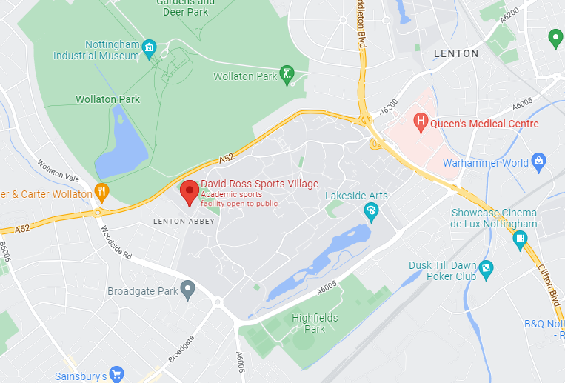
The hall (Salle) is located on the 1st floor.

BACKSTREETCOMPANY University of Nottingham 2* OPEN
On: Sunday 5th March 2023
A separate entry form must be completed by each player and to be EMAILED to Yameen Al-Dahiri:
alyameenal-dahiri@hotmail.co.uk
By no later than Friday 27th February 2023. All entrants should ensure that they have read the regulations, which apply to this tournament.

Payment will be made via: https://su.nottingham.ac.uk/shop?activity_id=131&category_id=6
- Visit the UoN Students Union Table Tennis page: https://su.nottingham.ac.uk/activities/view/table-tennis
- Go to Products & Merchandise
- Select and purchase ‘BackstreetCompany UoN 2* OPEN MIXED SINGLES ENTRY’

PLAYER'S NAME (Please complete in BLOCK CAPITALS)
ADDRESS
MOBILE
EMAIL
DATE OF BIRTH |  | MALE/FEMALE
TTE Membership No.
County of Affiliation
Club
National Association (if not affiliated to TTE)
Please detail any relevant disability, accessibility or health issues

Senior Mixed Singles | £25
Admin free | £2
TTE Levy  Basic Ranking and Table Tennis England Tournament levies (*£2 Tournament levy plus £1 per event for ranking levies) | £3
If you do not hold a Compete Plus membership, you must pay the appropriate Single Competition Licence fee.
Table Tennis England Single Competition Licence Fee
Single competition Licence Fee (£5 Juniors, £10 Seniors)
Total

I undertake to observe the regulations of the tournament, to abide by the decisions of the Referee, and to fulfil the schedule of play arranged for me unless prevented from doing so by circumstances beyond my control and accepted as such by the Referee

Table Tennis England require consent to the use of personal data in the administration of this competition, in accordance with the TTE Privacy Policy; the information will be shared where necessary with the organisers and event committee. For a player under 16 this consent must be given by a parent or guardian, who must also confirm agreement to the player’s participation in the competition. The TTE Privacy Policy is at https://www.tabletennisengland.co.uk/privacy-policy/

If player is 16 or over:

Data Protection: I am the player named above and I consent to the use by TTE of my personal data in the administration of this competition.

Signed:

Date:

If player is under 16:
Data Protection & Activity Consent: I have legal responsibility for the player named above and I consent to his/her participation in the competition, and to the use by TTE of his/her personal data in its administration.

Name: (block capitals)

Relationship to player:

Signed:

Date:

The UK Anti-Doping Rules apply to all persons entering an event or competition, for whichever is the longer of a) the length of their membership or licence period; or b) 12 months from the date of their participation, whether or not the entrant or licence holder is a citizen of, or resident in, the UK.

If player is under 18:
A player under 18 may not participate in a Table Tennis England event or competition unless a parent or guardian of that player has consented to testing of that player in the following form:

Anti-Doping Acknowledgment: I have legal responsibility for the player named above and I confirm that I have read the TTE Anti-Doping Regulations (Appendix P) and that I hereby acknowledge that the player is bound by these Regulations.

Name: (block capitals)

Relationship to player:

Signed:

Date:

