VETS 2 Man Team
Hereford

Point 4, Venns Lane, Hereford, HR1 1DT

Saturday 10 & Sunday 11 September 2022

TTE Ranking event 2*
(approved by TTE & Hereford CTTA)

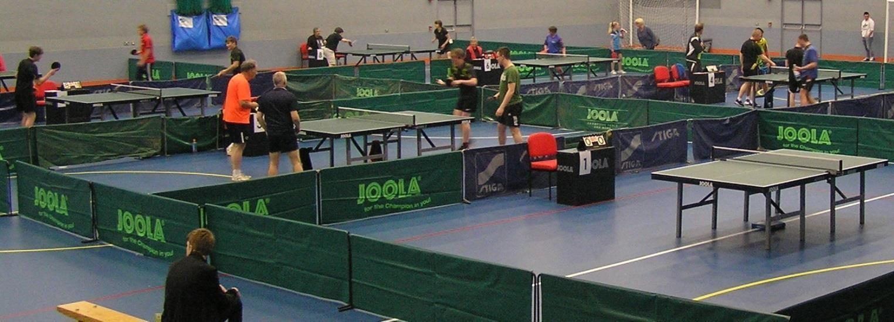

Account Details
HCTTA
Sort Code 53-50-41
Account Number 62463683

PLEASE USE YOUR TEAM NAME AS A REFERENCE ON BACS!!

And email entry form

Tournament Referee: Malcolm MacFarlane TR
Tournament Organiser: Kyle Day TO2
Entries to: Simon Morgan
136 Westfaling Street, Hereford, HR4 0JF
Tel: 07903 094128
E-Mail: simonmorgan1001@yahoo.co.uk
Organising Committee:
Kyle Day, Dylan Day, Simon Morgan, Richard Owens
Closing date for entries:
21 August 2022

INFORMATION: The leagues will be organised based on current ranking. Unranked players may be placed in a higher group if deemed appropriate by the Organising Committee.

LEAGUE REGULATIONS (to be retained)

- Every entrant must be affiliated as a Compete Plus Member or provide proof of being a member of another National Association affiliated to the ITTF, and is not affiliated to TTE. Players that only hold Compete membership of Table Tennis England may pay a Single Competition Licence Fee as a one-off upgrade and this provides entitlement to participate in this competition only. It is not possible to acquire membership of Table Tennis England at the tournament.
- Table Tennis England Tournament Regulations Part A (Regulated Competitions) and Part B (Tournament Regulations) apply to the tournament.
- ITTF Regulations for International Competitions apply to the tournament except where otherwise specified in TTE Regulations Part A or B, or in this form.
- Competitors will not be allowed to glue up within the confines of any of the buildings under any circumstances.
- All matches will be best of 5 games.
- Playing clothing shall consist of a shirt and shorts, trousers, leggings or skirt, or a one-part sports outfit, socks and playing shoes; a sports hijab may also be worn. Other garments shall not be worn during play except with the permission of the referee. The main colour of a shirt, shorts, trousers or skirt, other than sleeves and collar of a shirt, shall be clearly different from that of the ball in use.
- No competitor or official shall engage in betting on players or matches.
- All competitors will be required to umpire some matches.
- Doping shall not take place either before or during play and doping control tests may take place.
- For Veteran events, entrants must be born before the 1st of January 1983.
- Completion and submission of this entry form signifies agreement by the entrant to the conditions of the competition including variations of ITTF regulations.
- All Competitors must report to the Booking-In Control on arrival and should not leave the hall without first obtaining permission from the Referee. Players absent when called upon to play are liable to be scratched.
- Should there be insufficient entries in any event the Referee reserves the right to cancel that event/merge such event and/or place the entrant in a similar event.
- The referee’s decision shall be final on a point of law and on any question arising not provided for in these regulations, or in any dispute as to the interpretation thereof.
- All events will be based on the Table Tennis England ranking list effective on the closing date for entries. The organiser reserves the right to place any unranked players in the grade(s) he feels appropriate. All events will be seeded.

LEAGUE INFORMATION
- Entry forms - Further entry forms are available from and should be returned to Simon Morgan (Assistant Organiser), at simonmorgan1001@yahoo.co.uk or 136 Westfaling Street, Hereford, HR4 0JF; by 21 August 2022.
- The league will be formed on the 22 August 2022 at 136 Westfaling Street, Hereford, HR4 0JF at 1pm.
- No entry will be accepted after the draw has been made. If it becomes necessary to restrict entries, priority will be given in order of receipt.
- The event is a 2 man team event, only 2 players can play in any match, however a team can comprise of more players, there are 7 matches each weekend. In each match both players will play each other in a best of 5 singles match. So there are 4 matches in each fixture.
- Practice – There will be no separate practice facilities.
- Play will be on 12 Joola Tables with Joola nets and White Joola Flash 3* balls. Court size will be 11.5m x 6.9m enclosed by surrounds. Scoring machines will be used for all matches. The floor is a seamless polyurethane surface. General fluorescent lighting is 10m above the table. Assistant umpires will not be appointed.
- Car parking (at the owner’s risk) is available at the venue, there is an all-day charge of £5.
- Admission – there will be no admission charge.
- Changing rooms and showers can be used for showering or changing.
- There is some food and drinks available at venue café.
- A Cup will be awarded to each winning team from each of the leagues, but must be returned at the start of the next season for the next year’s leagues.
- There will be 3 Leagues of 8 teams.
- Players should retain this sheet of regulations and information.
- Full rules will be available on the League website – www.tabletennis365.com/HerefordTournaments

VETS 2 Man Team
Please complete in BLOCK CAPITALS using a ball-point pen. Details must be completed for each player and sent to the Assistant Organiser: Simon Morgan, 136 Westfaling Street, Hereford, HR4 0JF, simonmorgan1001@yahoo.co.uk
To arrive not later than 21 August 2022

Team Name:
Team Fee | £100
Single Competition Licence Fee (if no TTE Compete Plus Membership)  Covers both weekend! Only for any player/s that do not have TTE Compete Plus) | £10
All TTE levies covered by entry fee | Total: | £

Name
Address
DOB
Mobile
Email
Licence Number:
County Affiliation:
If not affiliated to TTE, name of National Association

NO ENTRY WILL BE ACCEPTED UNLESS THE FOLLOWING UNDERTAKING IS SIGNED:
I undertake to observe the regulations of the tournament, to abide by the decisions of the Referee, and to fulfil the schedule of play arranged for me unless prevented from doing so by circumstances beyond my control and accepted as such by the Referee.
Table Tennis England requires consent to the use of personal data in the administration of this competition, in accordance with the TTE Privacy Policy; the information will be shared where necessary with the organisers and event committee. The TTE Privacy Policy is at https://www.tabletennisengland.co.uk/privacy-policy/

Print Player Name ………………………………………………………………………………

If player is 16 or over:
Data Protection: I am the player named above and I consent to the use by TTE of my personal data in the administration of this competition.

Signed: ................................................................. Date …………………………………………

Directions

