PRESENTS THE
Butterfly St Neots Table Tennis Club
JUNIOR 4 STAR OPEN TABLE TENNIS TOURNAMENT
Held at Cambridge University Sport Centre
(APPROVED BY CTTA & Table Tennis England)
The tournament is included in the Computer Ranking Scheme.
7th & 8th May 2022
Referee: Dave Cochrane (NR) Deputy Referee: John Mackey (TR) Tournament Organiser: Jim Kenny (TO4)
Organising Committee:
D. Bullen (TO2), J. Bullen, D. Cochrane (TO4), J. Kenny (TO4) & Margaret Welch (TO3, Entry Secretary)

TOURNAMENT REGULATIONS (to be retained)
1. Every entrant must be affiliated as a Compete Plus Member or provide proof of being a member of another National Association affiliated to the ITTF and is not affiliated to TTE. An entrant only affiliated as a Compete Member may enter the tournament upon payment of the appropriate Single Competition Licence fee with their entry form.
2. TTE Regulations Part A (Regulated Competitions) and Part B (Tournament Regulations) apply to the tournament.
3. ITTF Regulations for International Competitions apply to the tournament except where otherwise specified in TTE Regulations Parts A or B, or in this form.
4. Completion and submission of this Entry Form signifies agreement by the entrant to the conditions of the competition including any variations of ITTF regulations.
5. Competitors may be required to umpire group matches at the discretion of the Referee.
6. All matches shall be the best of five games to eleven points. Play throughout will be on a knockout basis with the exception of preliminary rounds which may, at the discretion of the Referee, be on a group basis. The final order in a group shall be determined as per ITTF Regulation 3.7.5. for Group competitions.
7. Competitors in Junior events must have been born in 2003 or later.
Competitors in Cadet events must have been born in 2007 or later.
Competitors in Under 13 events must have been born in 2009 or later.
8. Playing clothing shall consist of a shirt and shorts, trousers, leggings or skirt, or a one-part sports outfit, socks and playing shoes; a sports hijab may also be worn. Other garments shall not be worn during play except with the permission of the referee. ITTF 3.2.2.1 amended. The main colour of a shirt, shorts, trousers or skirt, other than sleeves and collar of a shirt, shall be clearly different from that of the ball in use. ITTF 3.2.2.2 amended.
9. No competitor or official shall engage in betting on players or matches.
10. Doping shall not take place either before or during play.
11. All competitors must report to the Control Desk on arrival and must not leave the hall without first obtaining permission from the Referee. Players absent when called upon to play are liable to be scratched.
12. Competitors in Banded Singles events must not appear in the Table Tennis England Ltd Rating list current at the closing date of this tournament in the following positions (a) Junior Boys’ Band 1 Singles – top 50, Junior Boys’ Band 2 Singles - top 150, (b) Junior Girls’ Band 1 Singles – top 20, Junior Girls’ Band 2 Singles – top 100, (c) Cadet Boys’ Band 1 Singles – top 20, Cadet Boys’ Band 2 Singles – top 125, (d) Cadet Girls’ Band 1 Singles – top 10, Cadet Girls’ Band 2 Singles – top 100. Dummy rankings will be used for foreign entrants.
13. Should there be insufficient entries in any event the Referee reserves the right to cancel that event/merge such event and/or place the entrant in a similar event.
14. The Referee’s decision shall be final on points of law, and any question arising not provided for in these regulations, or in any dispute as to the interpretation thereof. Decisions on points of fact by an umpire or assistant umpire appointed by the Referee shall be final
15. Racket testing may take place.
16. No refunds will be given after the date of the draw.
Closing Date:
Friday 8th April 2022
Please return to: Mrs Margaret Welch Address:188 First Lane, Hessle, HU13 9EU or email
Welchm48@gmail.com

For further copies of this entry form please download at www.tabletennisengland.co.uk
The draw will take place on 20th April 2022 at 105 Clough Close, Middlesbrough. TS5 5ET.

Live streaming will take place at this event.

If you find you are unable to attend the event or need to contact the organisers over the weekend please ring:
Dave Cochrane on 07929 257817 or Dan Bullen on 07920 404411
Jim Kenny TO4
kennyjim2015@outlook.com
07846040488

TOURNAMENT INFORMATION
1. Entry Form - Further entry forms are available from, and should be returned to Mrs Margaret Welch Address:188 First Lane, Hessle, HU13 9EU or email to
Welchm48@gmail.com no later than Friday 8th April 2022 Cheques should be made payable to St. Neots Table Tennis Club Entries without fees will not be accepted.
2. Draw - The draw will take place on 20th May 2022 at 105 Clough Close, Middlesbrough. TS5 5ET. Once completed, and before the date of the tournament, the draw will be sent out and put on the club’s social media.
3. Admission - There will be no charge for admission.
4. Playing Conditions - Play throughout will be on 18 Butterfly Europa 25 tables, nets & posts, Butterfly R40 White plastic balls, wooden sprung floor and general LED 700 lux lighting 18m above the floor. Court size will be 10m x 5m and 20m from the floor to the ceiling enclosed by surrounds. Butterfly Scoring machines will be used for all matches.
5. Doping - Doping control tests may take place.
6. Practice - There will be no separate practice facilities. Competitors will be permitted to practice on tables not in use at the discretion of the Referee.
7. Car Parking - Car parking (at owner’s risk) is available at the venue in Car Park 8
8. Refreshments will be on sale throughout serving
Breakfast, lunch and tea.
9. Medals will be presented to winners and runners up in every event.
10. Changing rooms are available on site with men’s, women’s and disabled.

PROVISIONAL PLAYING SCHEDULE
Saturday:
8:45 Under 13s
11:00 Banded Cadet Singles
13:00 Cadet Open Singles
18:00 Finals
Sunday:
8:45 Banded Junior Singles
13:00 Junior Open Singles
18:00 Finals
The above is a guide only as the playing schedule will vary according to size of entry.

Door will open at 8am both days.

Trade Stand will be in attendance throughout the Tournament.

Junior 4* Tournaments – Entry Qualifications
If it becomes necessary to restrict entries, priority will be given in order of receipt, except that all valid entries for Junior Boys rated 1-50 in the Rating List current at the closing date and for Junior Girls, Cadet Boys and Cadet Girls rated 1-32 will be accepted, with priority thereafter being given to Junior Boys rated 51-500 and Junior Girls rated 33-250.

Sports Centre and Gym, University of Cambridge, Philippa Fawcett Dr, Cambridge, CB3 0AS
Please Park in Car Park 8

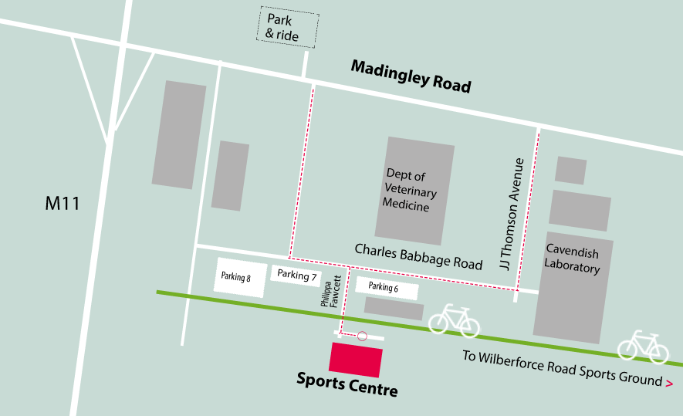

Butterfly St Neots Table Tennis Club
JUNIOR 4 STAR OPEN TABLE TENNIS TOURNAMENT
Held at Cambridge University Sport Centre

Events | Cost | Tick
Junior Boys Open | £18.50
Junior Boys Banded | £18.00
Junior Girls Open | £18.50
Junior Girls Banded | £18.00
Under 13 Boys | £17.00
Under 13 Girls | £17.00
Cadet Boys Open | £17.50
Cadet Boys Banded | 17.00
Cadet Girls | £17.50
Cadet Girl Banded | 17.50
Administration Fee | £4.00
Basic Ranking and Table Tennis England
1x Event | £3.00
2x Event | £4.00
3x Event | £5.00
4x Event | £6.00
5X Events | £7.00
If you do not hold a Compete Plus membership, you must pay the appropriate Single Competition Licence fee.  Table Tennis England Single Competition Licence | Junior £5
 | Cadet £5
Total to Pay
This form must be completed in BLOCK CAPITALS using a ball point pen. A separate entry form must be completed for each player and sent to the Entry Secretary: Mrs Margaret Welch Address:188 First Lane, Hessle, HU13 9EU or email
Welchm48@gmail.com
John Mitchell Address: 13 Greenfields, St. Neots, Cambridgeshire, PE191SL or email johnttmitchell@aol.com to arrive no later than the closing date. All entrants should ensure that they have read the conditions which apply to this tournament.

Competitors Name: Male / Female
Address:
Postcode: Date of Birth ……………………. Tel: ……………………………………. Email:……………………………………………
If not a member of Table Tennis England name of National Association: ……………………………………………
If a member of Table Tennis England state membership number: …………………………
County of Affiliation/ Residence:

Closing Date:
Friday 8th April 2022
Please return to: Mrs Margaret Welch Address:188 First Lane, Hessle, HU13 9EU or email
Welchm48@gmail.com

For further copies of this entry form please download at www.tabletennisengland.co.uk
The draw will take place on 20th April 2022 at 105 Clough Close, Middlesbrough. TS5 5ET.

Basic Ranking and Table Tennis England Tournament levies (*£2 Tournament levy plus £1 per event for ranking levies)

I undertake to observe the regulations of the tournament, to abide by the decisions of the Referee, and to fulfil the schedule of play arranged for me unless prevented from doing so by circumstances beyond my control and accepted as such by the Referee.
Table Tennis England require consent to the use of personal data in the administration of this competition, in accordance with the TTE Privacy Policy; the information will be shared where necessary with the organisers and event committee. For a player under 16 this consent must be given by a parent or guardian, who must also confirm agreement to the player’s participation in the competition. The TTE Privacy Policy is at https://tabletennisengland.co.uk/home/website-privacy-policy
If player is 16 or over:
Data Protection: I am the player named above and I consent to the use by TTE of my personal data in the administration of this competition.
Signed:
Date:
If player is under 16:
Data Protection & Activity Consent: I have legal responsibility for the player named above and I consent to his/her participation in the competition, and to the use by TTE of his/her personal data in its administration.
Name: (block capitals)
Relationship to player:
Signed:
Date:
If player is under 18
Anti-Doping Acknowledgment: I have legal responsibility for the player named above and I confirm that I have read the TTE Anti-Doping Regulations (Appendix P) and that I hereby acknowledge that the player is bound by these Regulations.
Name: (block capitals)
Relationship to player:
Signed:
Date:

