HEREFORD EASTER OPEN & VETS 2*

Point 4, Venns Lane, Hereford, HR1 1DT

Start Time: 8.45am

Saturday 16 & Sunday 17 April 2022

TTE Ranking event

(approved by TTE & Hereford CTTA)

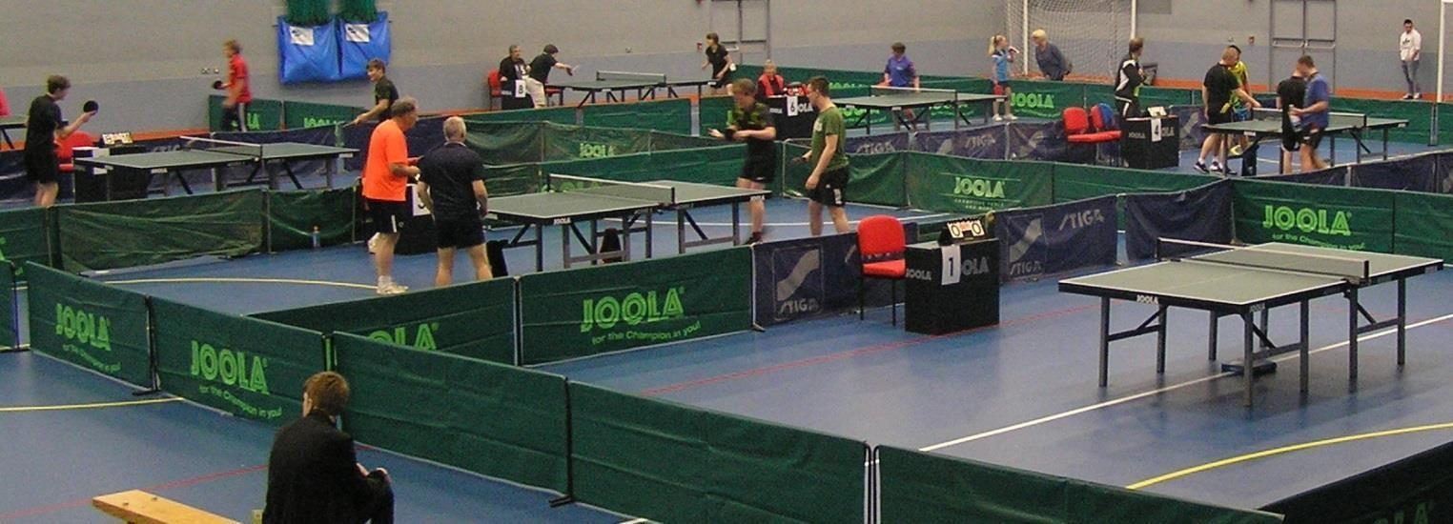

PLEASE PAY BY BACS

New Account Details
HCTTA
Sort Code 53-50-41
Account Number 62463683

PLEASE USE YOUR NAME AS A REFERENCE ON BACS!!

And email entry form

Tournament Referee: John Stalker TR
Tournament Organiser: Kyle Day TO2
Entries to: Simon Morgan
136 Westfaling Street, Hereford, HR4 0JF
Tel: 07903 094128
E-Mail: simonmorgan1001@yahoo.co.uk
Organising Committee:
Kyle Day, Dylan Day, Simon Morgan, Richard Owens
Closing date for entries:
10 April 2022

INFORMATION: This is an all-day competition open to male and female players. It will be run on a double group system followed by a knockout! The groups will be organised based on current ranking. Unranked players may be placed in a higher group if deemed appropriate by the Organising Committee.

TOURNAMENT REGULATIONS (to be retained)
- Every entrant must be affiliated as a Compete Plus Member or provide proof of being a member of another National Association affiliated to the ITTF, and is not affiliated to TTE. Players that only hold Compete membership of Table Tennis England may pay a Single Competition Licence Fee as a one-off upgrade and this provides entitlement to participate in this competition only. It is not possible to acquire membership of Table Tennis England at the tournament.
- Table Tennis England Tournament Regulations Part A (Regulated Competitions) and Part B (Tournament Regulations) apply to the tournament.
- ITTF Regulations for International Competitions apply to the tournament except where otherwise specified in TTE Regulations Part A or B, or in this form.
- Competitors will not be allowed to glue up within the confines of any of the buildings under any circumstances.
- Competition will be a mixture of groups and KO. All matches will be best of 5 games.
- The final order in a group shall be determined as per ITTF regulation 3.7.5 for group competitions.
- Playing clothing shall consist of a shirt and shorts, trousers, leggings or skirt, or a one-part sports outfit, socks and playing shoes; a sports hijab may also be worn. Other garments shall not be worn during play except with the permission of the referee. The main colour of a shirt, shorts, trousers or skirt, other than sleeves and collar of a shirt, shall be clearly different from that of the ball in use.
- No competitor or official shall engage in betting on players or matches.
- All competitors may be required to umpire at least one match in each event entered.
- Doping shall not take place either before or during play and doping control tests may take place.
- For Veteran events, entrants must be born before the 1st of January 1982.
- Completion and submission of this entry form signifies agreement by the entrant to the conditions of the competition including variations of ITTF regulations.
- All Competitors must report to the Booking-In Control on arrival and should not leave the hall without first obtaining permission from the Referee. Players absent when called upon to play are liable to be scratched.
- Should there be insufficient entries in any event the Referee reserves the right to cancel that event/merge such event and/or place the entrant in a similar event.
- The referee’s decision shall be final on a point of law and on any question arising not provided for in these regulations, or in any dispute as to the interpretation thereof.
- All events will be based on the Table Tennis England ranking list effective on the closing date for entries. The organiser reserves the right to place any unranked players in the grade(s) he feels appropriate. All events will be seeded.

TOURNAMENT INFORMATION
- Entry forms - Further entry forms are available from and should be returned to Simon Morgan (Assistant Organiser), at simonmorgan1001@yahoo.co.uk or 136 Westfaling Street, Hereford, HR4 0JF; by 9 April 2022.
- The draw will take place on the 10 April 2022 at 136 Westfaling Street, Hereford, HR4 0JF at 1pm. If it becomes necessary to restrict entries, priority will be given in order of receipt.
- No entry will be accepted after the draw has been made.
- The event is an all-day event, all players should get at least 7 matches.
- Practice – There will be no separate practice facilities.
- Play will be on 10 Joola Tables with Joola nets and White Tibhar SL 3* balls. Court size will be 11.5m x 6.9m enclosed by surrounds. Scoring machines will be used for all matches. The floor is a seamless polyurethane surface. General fluorescent lighting is 10m above the table. Assistant umpires will not be appointed.
- Car parking (at the owner’s risk) is available at the venue, there is an all-day charge of £5.
- Admission – there will be no admission charge.
- Changing rooms and showers can be used for showering or changing.
- There is some food and drinks available at venue café.
- Vouchers or trophies will be presented to all winners and runners-up.
- Players should retain this sheet of regulations and information.

Directions

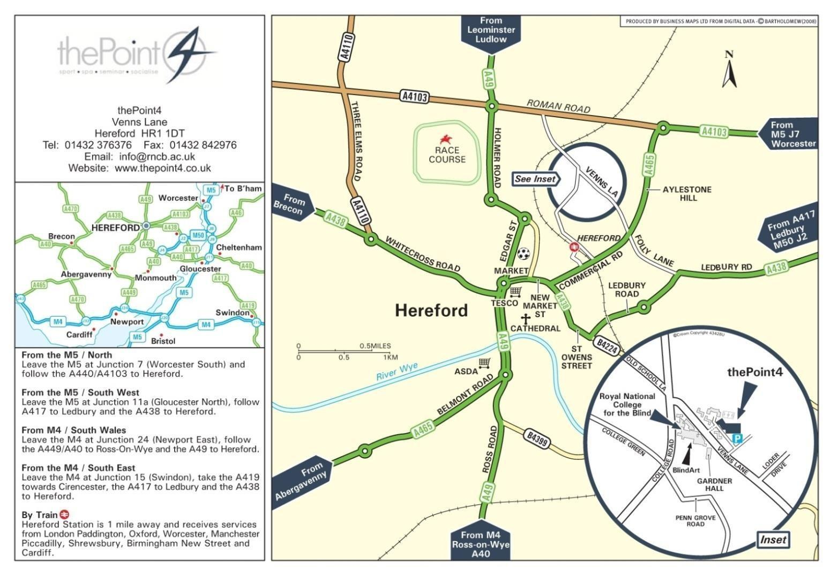
HEREFORD OPEN & VETS 2*
Please complete in BLOCK CAPITALS using a ball-point pen. A separate entry form must be completed by each player and sent to the Assistant Organiser: Simon Morgan, 136 Westfaling Street, Hereford, HR4 0JF, simonmorgan1001@yahoo.co.uk
To arrive not later than 9 April 2022

Name
Address
DOB
Mobile
Email

You must fill in Licence Number and County please!!

Table Tennis England Licence Number:
County of Affiliation:
If not affiliation to TTE, name of National Association

Saturday 16 April 2022 – Vets | £25.00
Sunday 17 April 2022 - Open | £25.00
Single Competition Licence Fee (if no TTE Compete Plus Membership) | £5.00
All TTE levies covered by entry fee | Total: | £

NO ENTRY WILL BE ACCEPTED UNLESS THE FOLLOWING UNDERTAKING IS SIGNED:
I undertake to observe the regulations of the tournament, to abide by the decisions of the Referee, and to fulfil the schedule of play arranged for me unless prevented from doing so by circumstances beyond my control and accepted as such by the Referee.
Table Tennis England requires consent to the use of personal data in the administration of this competition, in accordance with the TTE Privacy Policy; the information will be shared where necessary with the organisers and event committee. For a player under 16 this consent must be given by a parent or guardian, who must also confirm agreement to the player’s participation in the competition. The TTE Privacy Policy is at https://tabletennisengland.co.uk/home/website-privacy-policy

Print Player Name ………………………………………………………………………………

If player is 16 or over:
Data Protection: I am the player named above and I consent to the use by TTE of my personal data in the administration of this competition.

Signed: ................................................................. Date …………………………………………

If player is under 16:
Data Protection & Activity Consent: I have legal responsibility for the player named above and I consent to his/her participation in the competition, and to the use by TTE of his/her personal data in its administration.

Name: (Block Capitals) .............................................. Relationship to player: .............................. Signed: .................................... Date ……………………………..

If player is under 18:
Anti-Doping Acknowledgment I have legal responsibility for the player named above and I confirm that I have read the TTE Anti-Doping
Regulations (Appendix P) and that I hereby acknowledge that the player is bound by these Regulations.

Name: (Block Capitals) .............................................. Relationship to player: ............................... Signed: .................................... Date ……………………………...

