**Table Installation Considerations - Partners**

Table Tennis England/Ping! can offer guidance in fixing these tables (semi-permanent/permanent options), the final decision and execution of any groundworks should always be the responsibility of the recipient (or land owner) as only the people on site will be able to access the ground conditions and the possibility of underground services at the location.

Tables are at least 80kg, not ‘easily’ moved, but have been known to shift slightly with extreme winds so we **always** advocate on some form of fixing in position/installation.

The semi-permanent (Cornilaeu tables have a hole predrilled in each corner of the leg assembly, to take the supplied M8 x 40 Bolts & Plastic Plugs. On a good concrete/hard standing surface, these are sufficient although useful to recommend the type of expansion bolt, widely available from hardware stores.

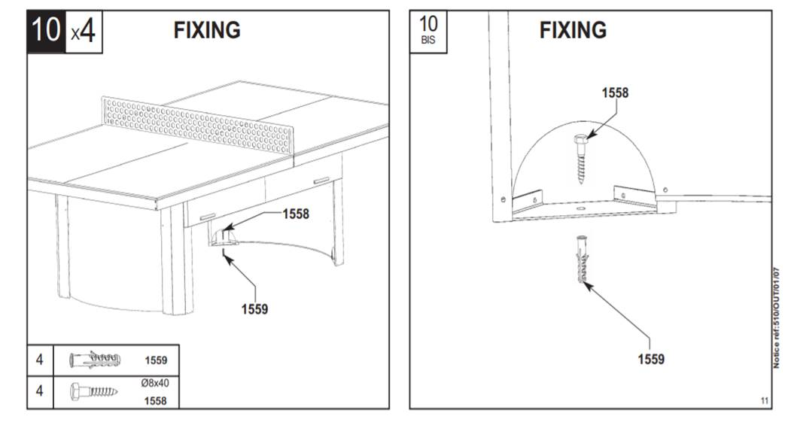

On a Tarmac or Grass surface, partners have sometimes preferred to use of “Rock Tent Pegs” as these can be screwed into the ground and are effective against inclement weather/wind and mild antisocial behaviour.

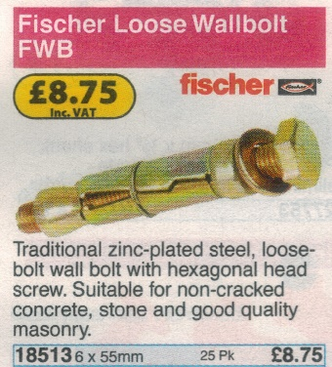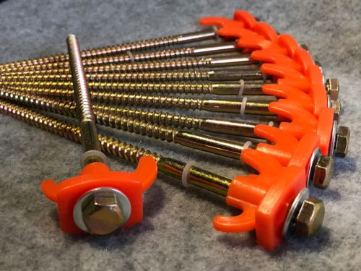

In some cases, partners have laid a flat concrete/gravel base for these tables, but at their own expense and having weighed up financially viability.

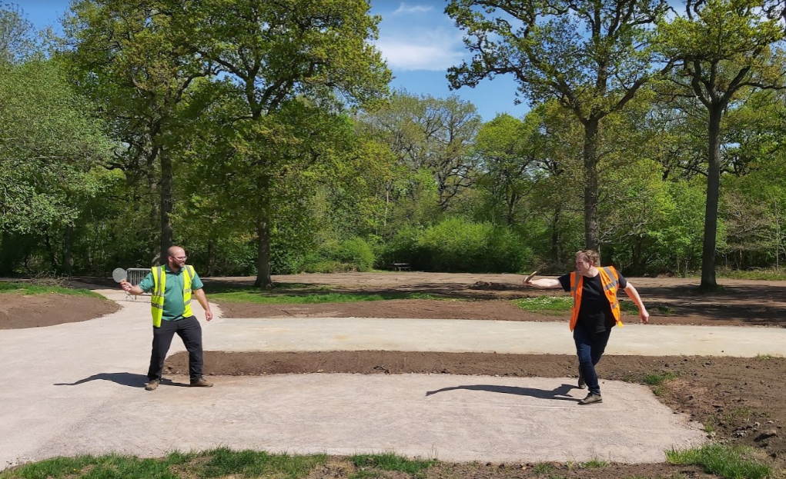

Partners have opted to add grass matting around the tables, again at their own expense and had their own rationale for doing that, i.e. preserve grass/look nice. Grass matting can add value and appeal to tables, preserving the ground and minimising trip/slips hazards.



