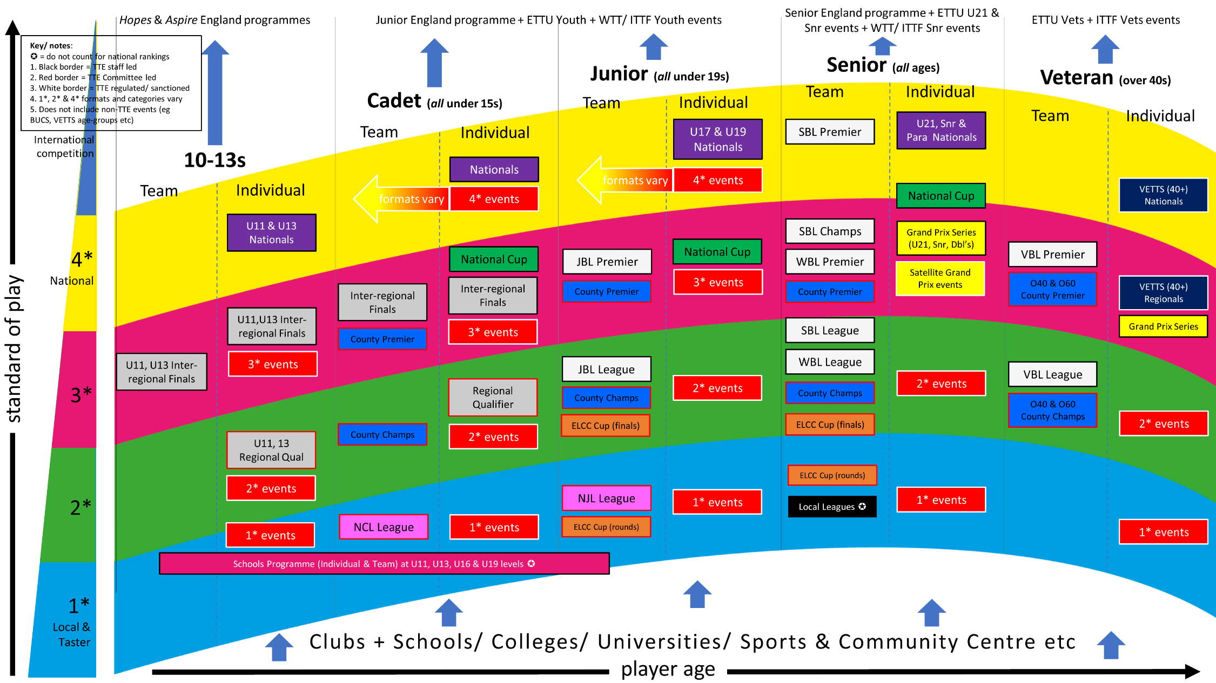

TTE-led Competitions
Programme | Description
Mark Bates Ltd. National Championships (closed) | A series of three annual KO tournaments for men’s and women’s individuals and doubles pairings at U11 & U13s, Cadet, U17 & Junior, and Para & U21 & Senior (open) age-groups. Restricted to the top32 England-eligible players, determined by rankings (and additionally through a separate qualification event for Senior, and leaderboard at 4* events for Cadet and Junior)
National Cups (closed) | A series of three annual tournaments for boys and girls at Cadet, Junior and Senior age-groups, played in a round-robin format. Restricted to the top10 England-eligible players, determined by rankings. The Senior event is new/ aspirational for season 21/22
British League (BL) (open) | A national merit league structure, in varying formats, for clubs/ teams at Junior boys and Junior girls (JBL), Senior (mixed/ open, SBL) Women’s (only, WBL) and Veterans men’s and women’s (VBL) age-groups. BL is the premier team-based competition in England, and also open to teams from other Home Countries. BL comprises over 300 teams, 1,400+ players, competing at c.30 home/ away fixtures, 6 national weekends & c.50 divisional weekends
Grand Prix (open) | A national series of five KO tournaments per season, held regionally, consisting of a broad mix of age-groups and events including U21 men’s and women’s singles, Senior (open) men’s and women’s singles and doubles, Veterans open doubles, and multiple Senior (open) men’s and women’s banded singles events determined by ranking points. Typically between 100-180 entrants for each tournament, averaging 2-3 events each
County Championships (closed) | A national merit league structure, hosted regionally below Premier level, for representative teams selected on players’ TTE county affiliation, at men’s and women’s Cadet, Junior, Senior, Veteran and Over-60 age-groups. Around 1,200 entrants. Also open to home countries counties.
National Cadet League (NCL) & National Junior Leagues (NJL) (open) | A programme of regionally-hosted league events, reconstituted on an annual basis, for mixed-gender clubs/ teams at Cadet and Junior age-groups. Aimed at grass-roots players, with c.250 Cadet and c.200 Junior participants
Inter-regional Qualifiers (closed) | An annual event, held at the discretion of each the ten TTE regions, and potentially also incorporating regional championships in other age-groups, to determine the individual regional qualifiers from boy’s and girl’s U11, U13 & Cadet age-groups to attend the Inter-regional Finals. Restricted to England-eligible players affiliated to TTE counties within a specific TTE region
Inter-regional Finals (closed) | An annual KO tournament in both team and individual formats, at boy’s and girl’s U11, U13 & Cadet age-groups, for c.200 singles and c.100 team participants qualifying or selected from Inter-regional Qualifier events. The event is specifically aimed at the tier of players below the top10, and therefore entry is restricted to those outside the top10 rankings or already invited to National Cups
English League Cup Competition (ELCC) (closed) | An annual KO tournament in team format, at Junior and Senior age-groups, for representative teams selected on players’ TTE local league participation. A national finals event follows zonal qualification tournaments, with c.150 participants. This is the oldest event on the Table Tennis England calendar.
Butterfly Schools (closed) | Consists of both Team and Individual events, for boys and girls, at U11, U13, U16 and U19 age-groups. Entrants represent their school and require permission to compete. TTE deliver Regional and National finals in the team event, and national finals in the individual event, following Borough Finals > County Finals > Zone Finals delivered by schools at local level. National finals consists of around 330 entrants to the individuals event, and 120 in the team event.
Jack Petchey Schools (closed) | With the support of the Jack Petchey Foundation, TTE also deliver the County rounds of the Butterfly Schools competition in London & Essex, and the Zone finals for the Team event in London. For the individual competition, there is also a London Final for those qualifying from the County Finals
Externally-led Competitions
Description | Description
Local Leagues (open) | A wide-ranging annual merit league structure, club-based at local level, in varying formats, typically for clubs/ teams at Senior (open) age-group. There are c.230 sanctioned local leagues consisting of around 2,500 clubs fielding 7,000 teams. Local leagues are non-regulated but supported by TTE, and typically take place on weekday evenings
1*, 2*, 3* & 4* events (open) | A wide-ranging tournament programme, typically club-based at local level, in varying formats. There are c.160 sanctioned 1*, 2*, 3* & 4* events each season, regulated by TTE – these are the most frequent and accessible tournament events for players
Satellite Grand Prix (open) | Complimentary event consistent with Grand Prix format, regulated by TTE, but externally- rather than internally-led. Typically two events each season held within UK but out with England (eg in Jersey and Wales)
VETTS (closed) | A national series of seven KO tournaments, held regionally, for members of the VETTS organisation. Sanctioned and regulated by TTE at 40+ (Veteran) age-group only, with additional non-regulated age-group events also held in 50+, 60+, 70+ & 80+ age-groups

Please note that for Season 21/22 Junior event eligibility has been changed from U18 to U19, and the age-groups for National Championships and National Cups have been amended from previous season

Yorkshire, North West, North East, West Midlands, East Midlands, South West, South, London, South East, Eastern

