COUNTY SCHOOLS’

TABLE TENNIS ASSOCIATION
TEAM
CHAMPIONSHIPS
Day, Date, Year, Time
Venue
Venue Address
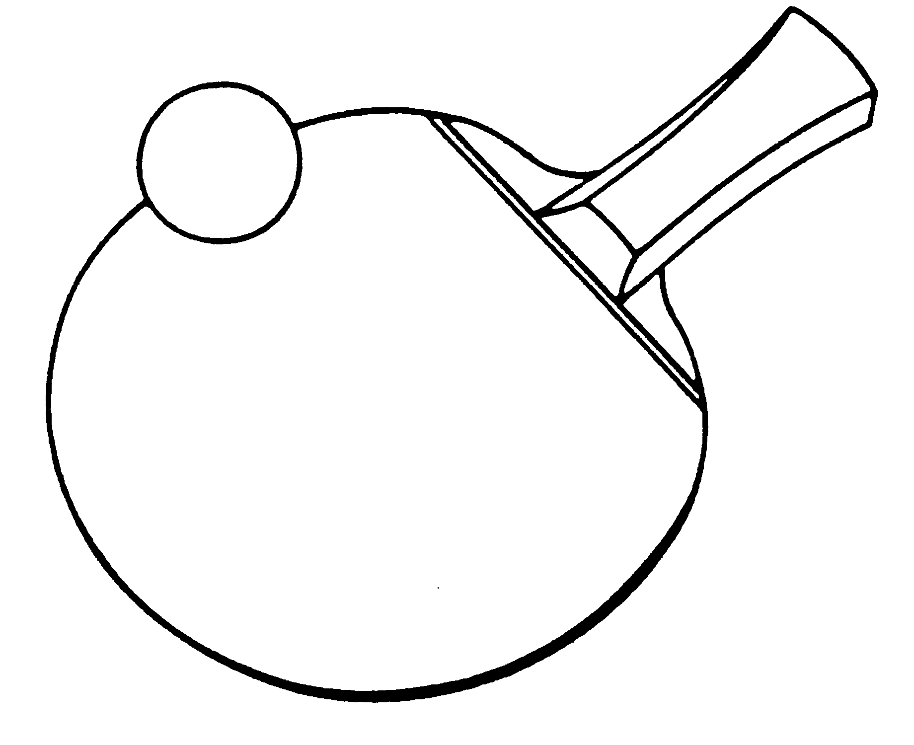

Closing date for entries: Date

This event is a qualifying competition for the
Butterfly School Team Championship Zone Finals
RULES

1. All participating Schools and Colleges must be affiliated to their respective County Schools T.T.A.
2. Four players per team to play in ranked order except in the Girls' Under 19 team which will consist of only two players. All players must be in FULL TIME education.
3. Eight events – Boys’ and Girls’ under-19, under-16, under-13, and under-11. Ages as at 1st September xxxx (Current School Year).
4. At least one playing member of each team MUST be competing in the youngest event for which he/she is eligible. e.g. An Under 19 team MUST have at least one playing member of the team who is ineligible for U16/U13/U11 events.
5. Players may only play in one event.
6. Playing clothing shall consist of a shirt and shorts, trousers, leggings or skirt, or a one-part sports outfit, socks, and playing shoes. A sports hijab may also be worn. Other garments, shall not be worn during play except with the permission of the referee.
7. The main colour of a shirt, shorts, trousers or skirt, other than sleeves and collar of a shirt, shall be clearly different from that of the ball in use.
8. Entries to the Organiser by Day, Date.
9. Players, or teachers in charge should report to control by time.
10. Late arrivals are liable to be scratched.
11 No entries will be accepted unless accompanied by the appropriate entry fee.
12. Matches will be played best of 3 or 5 games (dependent upon time), 11 points up, changing service after every 2 points.
13. The winning teams in each age group will represent their county in the Butterfly School Team Championship Zone Finals.

The full Team Championship Regulations can be found on the schools section of the Table Tennis England website
COUNTY SCHOOLS’ TABLE TENNIS ASSOCIATION
Team Championships

ENTRY FORM
Name of School:
Address of School:
Post Code:
Teacher in charge:
E-mail:
Mobile No: (for emergencies)
Signed:
Headteacher/Deputy Headteacher
NB: This form must be signed by the Headteacher/Deputy Headteacher signifying their support and approval

EVENTS: (Tick events to be entered)
I would like to enter a team in the Boys’ under-19 event
I would like to enter a team in the Girls’ under-19 event
I would like to enter a team in the Boys’ under-16 event
I would like to enter a team in the Girls’ under-16 event
I would like to enter a team in the Boys’ under-13 event
I would like to enter a team in the Girls’ under-13 event
I would like to enter a team in the Boys’ under-11 event
I would like to enter a team in the Girls’ under-11 event
I enclose the entry fee for xx teams at £xx per team. Total £ ________
Cheques should be made payable to County S.T.T.A.

Please return to:
Name, Address, Post Code
by Day, Date
Telephone:
Email:

