COUNTY SCHOOLS' TABLE TENNIS ASSOCIATION
INDIVIDUAL CHAMPIONSHIPS

ENTRY FORM
Please enter the following players, listed in ranked order.

BOYS | GIRLS
UNDER 19 (6th Form)  1.  2.  3.  4. | UNDER 19 (6th Form)  1.  2.  3.  4.
UNDER 16 (Yr 9, 10, 11)  1.  2.  3.  4. | UNDER 16 (Yr 9, 10, 11)  1.  2.  3.  4.
UNDER 13 (Yr 7, 8)  1.  2.  3.  4. | UNDER 13 (Yr 7, 8)  1.  2.  3.  4.
UNDER 11 (Primary)  1.  2.  3.  4. | UNDER 11 (Primary)  1.  2.  3.  4.
COUNTY SCHOOLS’
TABLE TENNIS ASSOCIATION
INDIVIDUAL
CHAMPIONSHIPS
Day, Date, Year, Time
Venue
Venue Address
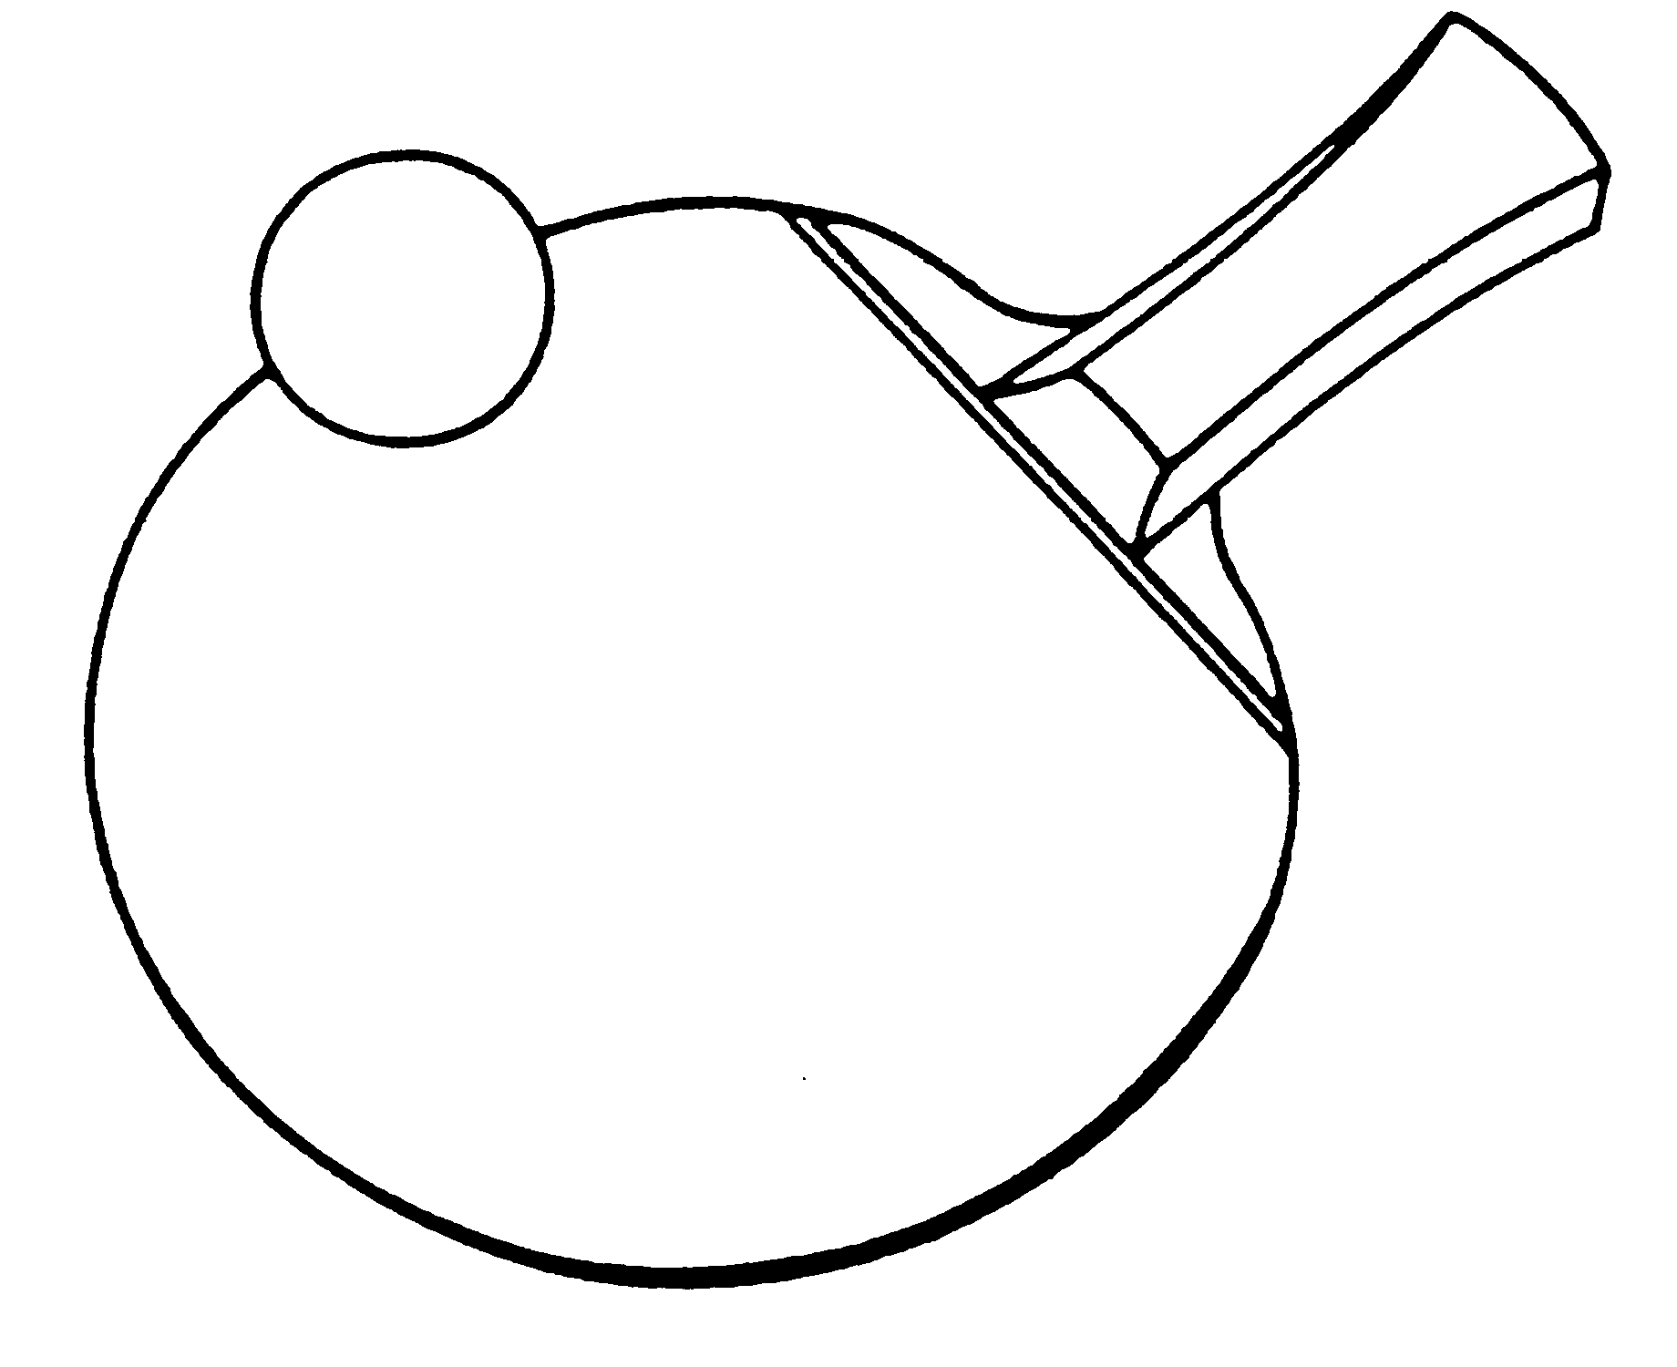

Closing date for entries: Date
This event is a qualifying competition for the
Butterfly Schools' National Individual Championship Finals

RULES

- All players must attend an affiliated school or college and be in full time education.
- Eight events – Boys’ and Girls’ under-19, under-16, under-13, and under-11. Ages as at 1st September xxxx (Current School Year).
- Players may enter ONE EVENT only.
- Schools should not enter more than four players in any one event.
- Entries to the Organiser by Day, Date.
- Players, or teachers in charge should report to control by time.
- Late arrivals are liable to be scratched.
- Playing clothing shall consist of a shirt and shorts, trousers, leggings or skirt, or a one-part sports outfit, socks, and playing shoes. A sports hijab may also be worn. Other garments, shall not be worn during play except with the permission of the referee.
- The main colour of a shirt, shorts, trousers or skirt, other than sleeves and collar of a shirt, shall be clearly different from that of the ball in use.
- All correspondence or requests for information re the competition should be addressed to the Organiser.
- Matches will be played best of 5 games, 11 up changing service after every 2 points.

No entries will be accepted unless accompanied by the appropriate fees.

It is hoped to play in groups. The number in each group will depend on the size of entry.

The winner of each age group will represent their county in the Butterfly National Schools' Individual Championships.

COUNTY SCHOOLS’ TABLE TENNIS ASSOCIATION
Individual Championships

ENTRY FORM
Name of School:
Address of School:
Post Code:
Teacher in charge:
E-mail:
Mobile No: (for emergencies)
Signed:
Headteacher/Deputy Headteacher

N.B. This form must be signed by the Headteacher/Deputy Headteacher signifying their support and approval

I enclose the entry fee for xxxx players at £xx each. Total £ _______

Cheques should be made payable to County S.T.T.A.

Please list players overleaf
(if more space is required please attach separate sheet)

Please return to:
Name, Address, Post Code
by Day, Date
Telephone:
Email:

LATE ENTRIES WILL NOT BE ACCEPTED

